# Build a Battle Station App

Build a simple event management app with Apex and Visualforce.

## Introduction

In this project, you will learn how to build an application on the Salesforce Platform from start to finish, without writing any code. If you're new to the Salesforce Platform, the goal is to introduce you to the basics of app building. It's fun, easy and won't leave you short of breath.

 These same point-and-click skills are applicable to building almost anything on the Salesforce Platform. Here's what you'll be doing:

* Create the app and a data model for the application. This simple application requires only a few custom objects with a small number of fields.
* Modify the user interface on the browser and on the Salesforce mobile app using page layouts, compact layouts, and global actions.
* Implement business logic using formulas, validation rules and a process builder.
* Build reports and dashboards to track the status of supplies and analyze how well the company manages resources.

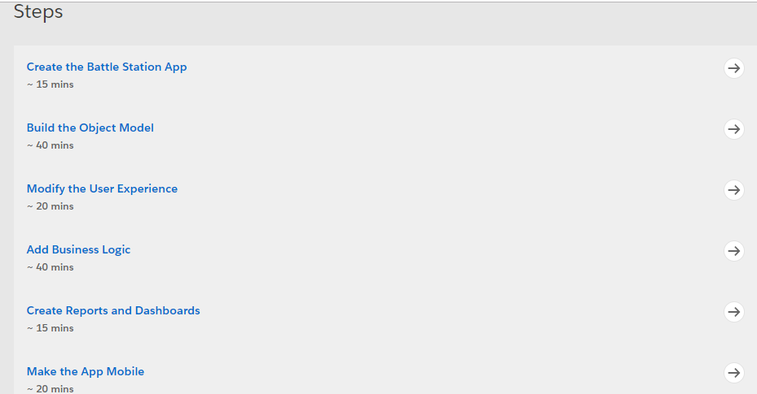

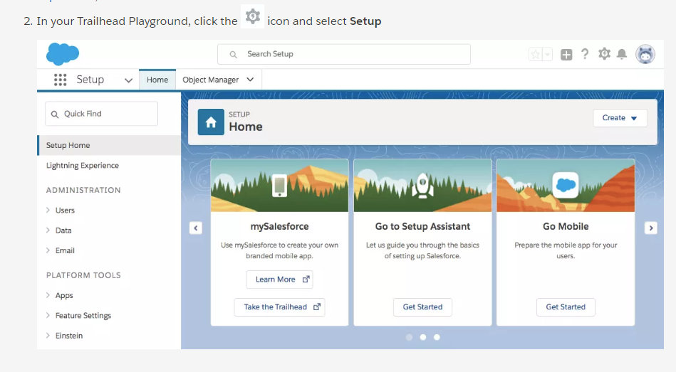

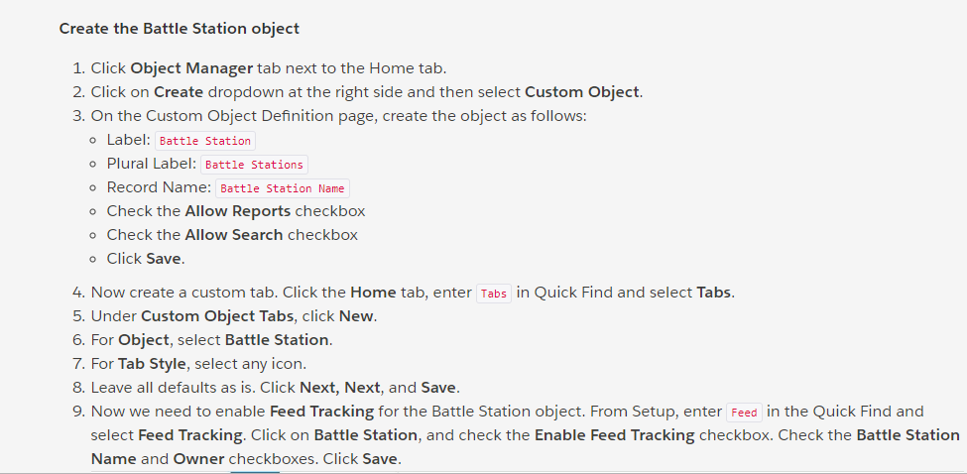

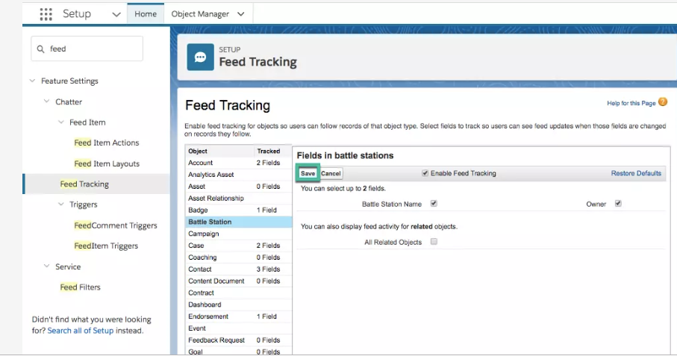

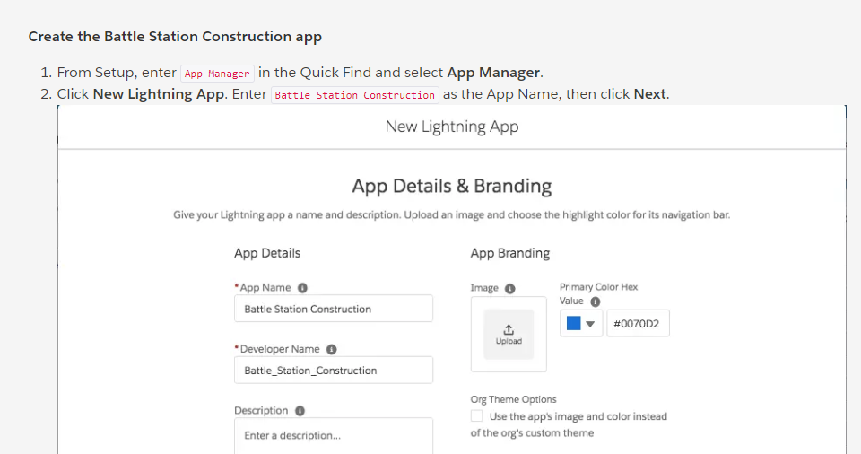

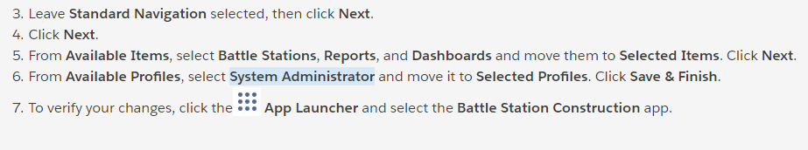

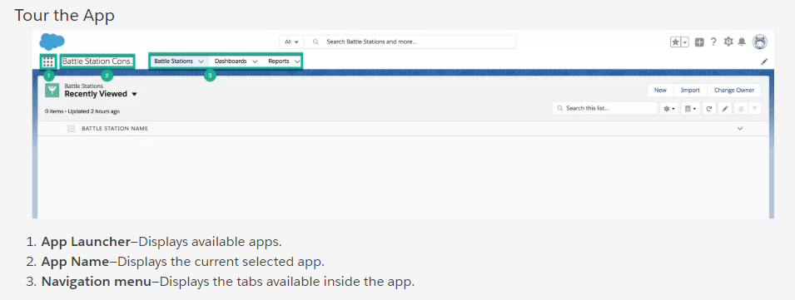

# Build the Object Model

### **What You’ll Do**

* Add fields to the Battle Station custom object.
* Create a Resource custom object and fields.
* Create a Supply custom object and fields.

There are two types of objects:

* **Standard Objects**—These are objects included with Salesforce, by default, for example the objects used to store data in standard tabs such as accounts, contacts, or opportunities. So if you ever want to sell timeshares in your Battle Station, the CRM functionality is already there.
* **Custom Objects**—These are new objects you create to store information unique to your application. Custom objects extend the functionality that standard objects provide. For our Battle Station Construction app we'll be using Custom Objects exclusively.

## Data Model

Our application will use three custom objects:

1. **Battle Station**—This will be our main object that tracks the status of the project, its supplies and resources.
2. **Resource**—Projects are about doing "stuff" and you need resources (that is, people) to do "stuff." We'll use the resources custom object to track the number of people working on the construction project and how much time they are committed to it.
3. **Supply**—You also need supplies and equipment to build a Battle Station. We'll use this object to track our supplies and their costs.

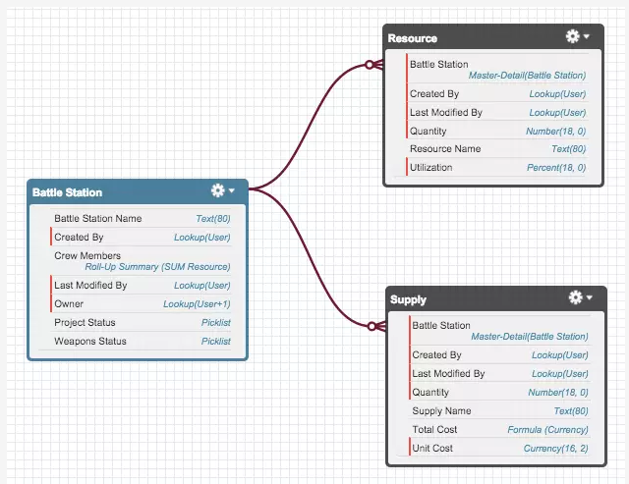

## Battle Station Custom Object

In the previous step, we built our Battle Station custom object. Now we need to make custom fields for that object.

1. Click  and select **Setup**. This launches Setup in a new tab.
2. Click the **Object Manager** tab next to Home.
3. Select **Battle Station**.
4. Select **Fields & Relationships** from the left navigation, and click **New**.

Now we're ready to make a custom field. Let's do this!

#### Step 1: Add a Project Status field

You'll create a picklist field so that users can select from a predefined list of available statuses.

Create the **Project Status** field as follows:

1. For Data Type, select **Picklist**, and click **Next**.
2. Fill in the custom field details:
   * Field Label: Project Status
   * Check the radio button next to **Enter values, with each value separated by a new line.**
   * Enter the following values for the picklist (one per line):
     + Green
     + Yellow
     + Red
     + Complete
   * Display values alphabetically, not in the order entered - **Unchecked**.
   * Use first value as default value - **Checked**.
   * **Uncheck** the **Restrict picklist to the values defined in the value set** box.
3. Leave the defaults for the remaining fields, and click **Next**.
4. Click **Next** again to accept the default field visibility and security settings.
5. Click **Save & New** to add the Project Status field to the page layout, save the Project Status field, and return to the first step of the wizard.

#### Step 2: Add a Weapons Status field

The main purpose of a Battle Station is to blow stuff up. We need to keep track of weapons, primarily the planet destroying type, and what their current status is.

Similar to the Project Status, you'll create a picklist field so that users can select from a predefined list of available statuses.

Create the **Weapons Status** field as follows:

1. For Data Type, select **Picklist**, and click **Next**.
2. Fill in the custom field details:
   * Field Label: Weapons Status
   * Check the radio button next to **Enter values, with each value separated by a new line.**
   * Enter the following values for the picklist (one per line):
     + Not Yet Operational
     + Fully Operational
   * Display values alphabetically, not in the order entered - **Unchecked**.
   * Use first value as default value - **Checked**.
   * **Uncheck** the **Restrict picklist to the values defined in the value set** box.
3. Leave the defaults for the remaining fields, and click **Next**.
4. Click **Next** again to accept the default field visibility and security settings.
5. Click **Save** to add the Weapons Status field to the page layout, save the Weapons Status field, and return to the Battle Station Custom Object page.

## Resource Custom Object

When building a Battle Station you have to have resources to do the actual work. There's no magical force flowing through the universe that will do it for you. You need people, and a way to track their usage. That's what our Resource object will do.

1. Click  and select **Setup**. This launches Setup in a new tab.
2. Click the **Object Manager** tab next to Home.
3. Click on **Create** dropdown and then select **Custom Object**.
4. On the Custom Object Definition page, create the object as follows:
   * Label: Resource
   * Plural Label: Resources
   * Record Name: Resource Name
   * Check the **Allow Reports** checkbox
   * Click **Save**.
5. Now create a custom tab. Click the **Home** tab, enter Tabs in Quick Find and select **Tabs**.
6. Under **Custom Object Tabs**, click **New**.
7. For **Object**, select **Resource**.
8. For **Tab Style**, select any icon.

Leave all defaults as is. Click **Next, Next**, and **Save**.

Now we have to create a couple of fields like we did with the Battle Station. Click the **Object Manager** tab next to Home and select the **Resource** custom object. Select the **Fields & Relationships** section and click the **New** button.

### **Step 1: Add a Quantity field**

The Resource Name tracks the type of crew we need (e.g., plumber, exhaust port inspector, massage therapist) so now we need a field that determines how many resources of each type we need.

Create the **Quantity** field as follows:

1. For Data Type, select **Number**, and click **Next**.
2. Fill in the custom field details:
   * Field Label: Quantity
   * Ensure that there is always a number entered for this field by checking the **Required** checkbox.
3. Leave the defaults for the remaining fields, and click **Next**.
4. Click **Next** again to accept the default field visibility and security settings.
5. Click **Save & New** to add the Quantity field to the page layout, save the Quantity field, and return to the first step of the wizard.

### **Step 2: Add a Utilization field**

When resources are working on a project they might not be committed full time. They may work 50% on one project and 50% on another for instance. This is a resource's utilization and it's important to track when you want to look at metrics and scheduling.

Create the **Utilization** field as follows:

1. For Data Type, select **Percent**, and click **Next**.
2. Fill in the custom field details:
   * Field Label: Utilization
   * Ensure that there is always a percentage entered for this field by checking the **Required** checkbox.
3. Leave the defaults for the remaining fields, and click **Next**.
4. Click **Next** again to accept the default field visibility and security settings.
5. Click **Save & New** to add the Utilization field to the page layout, save the Utilization field, and return to the first step of the wizard.

### **Step 3: Add a Battle Station field (Master-Detail Relationship)**

Resources are assigned to work on a specific Battle Station so we need to create this relationship between the objects. You'll be creating a Master-Detail relationship from Resources to Battle Station.

This creates a special type of relationship between two objects (the child, or "detail") and another object (the parent, or "master"). Plus, the relationship provides all sort of extra benefits. We'll go over one of those in a second.

Create the **Battle Station** relationship field as follows:

1. For Data Type, select **Master-Detail Relationship**, and click **Next**.
2. Select **Battle Station** from the Related To picklist, and click **Next**.
   * Field Label: Should default to **Battle Station**
   * Field Name: Battle_Station
3. Leave the defaults for the remaining fields, and click **Next**.
4. Click **Next** again to accept the default field visibility and security settings.
5. Click **Next** to add the Battle Station field to the page layout.
6. Click **Save** to add the Battle Station field to the page layout, the related list of Battle Station records to the page layout (we'll go into more detail in a second), save the Battle Station field, and return to the Resource Custom Object page.

## Supplies Custom Object

This brings us to our last custom object. To build our Battle Station we need supplies and equipment such as cosmic wave generators, donuts, armor wax, laser guns, mustache wax and such. This stuff costs money so we want to track our costs to make sure we stay under budget and are not called into the boss's office.

To get back to Object Manager, click  and select **Setup**. Click on **Object Manager** tab next to Home. Click the **Create** dropdown and then select Custom Object again to get started. This should feel very familiar to you by now.

1. On the Custom Object Definition page, create the object as follows:
   * Label: Supply
   * Plural Label: Supplies
   * Check the **Allow Reports** checkbox
   * Click **Save**.
2. Now create a custom tab. Click the Home tab, enter Tabs in Quick Find and select **Tabs**.
3. Under **Custom Object Tabs**, click **New**.
4. For **Object**, select **Supply**.
5. For **Tab Style**, select any icon.
6. Leave all defaults as is. Click **Next, Next**, and **Save**.

Now we have to create a couple of fields like we did with the Battle Station. Click the **Object Manager** tab next to Home and select the **Supply** custom object. Select the **Fields & Relationships** section and click the **New** button.

### **Step 1: Add a Quantity field**

When we order light bulbs or armor wax, we need to track the quantity.

Create the **Quantity** field as follows:

1. For Data Type, select **Number**, and click **Next**.
2. Fill in the custom field details:
   * Field Label: Quantity
   * Ensure that there is always a number entered for this field by checking the **Required** checkbox.
3. We want to encourage our users to order at least 2 of any supply (we always like to have a back up), so we'll set the **default value** to **2**.
4. Leave the defaults for the remaining fields, and click **Next**.
5. Click **Next** again to accept the default field visibility and security settings.
6. Click **Save & New** to add the Quantity field to the page layout, save the Quantity field, and return to the first step of the wizard.

### **Step 2: Add a Unit Cost field**

We also need to record how much each unit of our supply or equipment costs. For instance, if we order 1,000 inflatable bath toys we want to track that they are $2.75 each.

Create the **Unit Cost** field as follows:

1. For Data Type, select **Currency**, and click **Next**.
2. Fill in the custom field details:
   * Field Label: Unit Cost
   * Length: 16
   * Decimal Places: 2
   * Ensure that there is always a number entered for this field by checking the **Required** checkbox
3. Leave the defaults for the remaining fields, and click **Next**.
4. Click **Next** again to accept the default field visibility and security settings.
5. Click **Save & New** to add the Unit Cost field to the page layout, save the Unit Cost field, and return to the first step of the wizard.

### **Step 3: Add a Total Cost field (Formula Field)**

Now that we have the quantity of each item and the unit cost for each item, you obviously want to know the total cost for all items. Instead of manually calculating these costs (quantity * unit cost = total), you can let the Salesforce Platform do the work for you using a Formula Field! These fields are calculated at run-time much like formulas in a spreadsheet. They make life so much easier.

Create the **Total Cost** formula field as follows:

1. For Data Type, select **Formula**, and click **Next**.
2. Fill in the custom field details:
   * Field Label: Total Cost
   * Field Name: Total_Cost
   * Formula Return Type: **Currency**
   * Decimal Places: 2
3. Click **Next**.
4. Since we want to see the total cost for each supply record, enter the following for the formula: Quantity__c * Unit_Cost__c, and click **Next**.
5. Click **Next** again to accept the default field visibility and security settings.
6. Click **Save & New** to add the Total Cost field to the page layout, save the Total Cost field, and return to the first step of the wizard.

### **Step 4: Add a Battle Station field (Master-Detail Relationship)**

Just like resources, with supplies we need to relate them to a specific Battle Station record using a master-detail relationship.

Create the **Battle Station** relationship field as follows:

1. For Data Type, select **Master-Detail Relationship**, and click **Next**.
2. Select **Battle Station** from the Related To picklist, and click **Next**.
   * Field Label: Should default to **Battle Station**
   * Field Name: Battle_Station
3. Leave the defaults for the remaining fields, and click **Next**.
4. Click **Next** again to accept the default field visibility and security settings.
5. Click **Next** to add the Battle Station field to the page layout.
6. Click **Save** to add the Battle Station field to the page layout, the related list of Battle Station records to the page layout and save the Battle Station field, and return to the Supply Custom Object page.

# Modify the User Experience

Page layouts allow you to customize the look and feel of detail and edit pages in Salesforce.

You can also use page layouts to control which fields, related lists, and custom links users see, which standard and custom buttons appear on detail pages and related lists, and determine whether fields are visible, read only, or required on detail and edit pages. Yes... you can do a lot with page layouts.

## Modify the Battle Station Page Layout

You are going to move some fields around and add a few related lists to make the user interface more productive and appealing.

You can edit the page layout from the Custom Object definition page. But first you need to add a new Battle Station record.

Click the  to access the App Launcher, then select the **Battle Station Construction** app. Click the **Battle Stations** tab, then the **New** button. Enter any name that you'd like for your Battle Station (Obliteration Station has a nice ring to it!) and then **Save** the record.

What you see now is the default layout for the Battle Station that the Salesforce Platform generated for you. Let's move some fields around to make this easier to work with. We'll move the Project and Weapons Status fields to the right a little.

1. Click  and select **Setup**. This launches Setup in a new tab.
2. Click the **Object Manager** tab next to Home.
3. Click the name of your object (in this example, click Battle Station)
4. Select the **Page Layouts** and select the **Battle Station Layout**.
5. Scroll down to the Battle Station Detail section and drag the **Project Status** field to the right column.
6. Drag the **Weapons Status** field to the right column.

There's a lot more info for the related list records than is currently showing. Edit the layout for the related lists to include more info on the page.

1. Click the wrench icon next to the **Resources** label in the related list to bring up the properties editor modal.
2. Add the **Quantity** and **Utilization** field to the right side by selecting them and clicking the **Add** arrow in the middle.
3. Click **OK** to close the modal.

Do the same thing for the **Supplies** related list and add the **Quantity**, **Unit Cost**, and **Total Cost** fields, in that order.

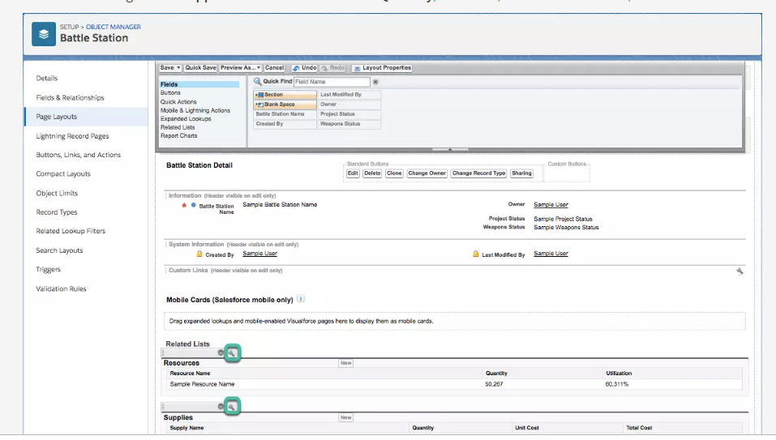

## **Add Some Battle Station Data**

Now that you have your page layout looking awesome, it's time to enter some data so you can really get a feel how the application functions.

It takes a large number of people to build and operate a Battle Station so let's assign some resources to your project. Enter some resource records and set the quantities you may need plus a target utilization percentage. Feel free to be as creative as you'd like. Here are some types of resources you might need to build your Battle Station:

Click the  to access the App Launcher, then select the **Battle Station Construction** app. Click the **Battle Stations** tab, and then select the **Obliteration Station** record. Under the **Related** tab, click **New** on the **Resources** list.

* Dark Lord
* Admiral
* Construction worker
* Left-handed monkey wrench adjuster
* Robert the foreman
* Exhaust port inspector

# Add Business Logic

### **What You’ll Do**

* Create a Validation Rule
* Create an automated process with Lightning Process Builder

So now we have our basic app in place and users can maintain data and manage the project. However, we have some business rules for these type of projects that we'd like to put into place.

## Add a Utilization Validation Rule

1. Click  and select **Setup**. Select **Object Manager** tab next to the Home tab.
2. Click **Resource**.
3. Select the **Validation Rules** section from the left navigation.
4. Click the **New** button.
5. For the **Rule Name** enter: Inspectors_Must_Work_Overtime
6. For the Error Condition Formula, you want to prevent the record from being
7. saved for an Exhaust Port Inspector with a utilization of less than 150%. Enter the formula as AND(Name = "Exhaust Port Inspector", Utilization__c < 1.5).
8. Click the **Check Syntax** button to make sure the formula has the correct syntax
9. For the Error Message enter: **Exhaust Port Inspectors must work at least 150%. No coffee breaks!**
10. For the Error Location click the **Field** radio button and then select the **Utilization** field.

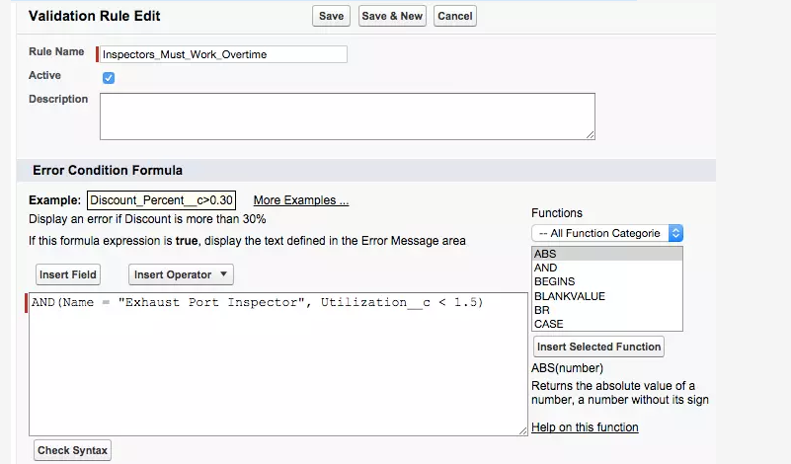

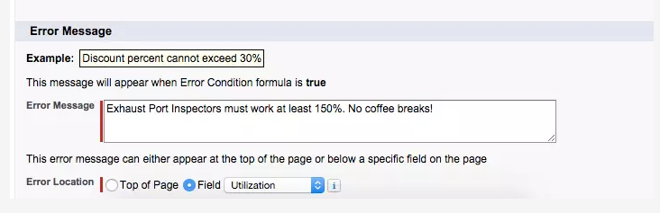

10. Click the **Save** button.

Now go back to your Battle Station record and enter a new resource type of **Exhaust Port Inspector** with a utilization less than **150**. You should now see an error message preventing users from entering "bad" data.

## **Automate with the Lightning Process Builder**

The Lightning Process Builder is a workflow tool that helps you easily automate your business processes by providing a powerful and user-friendly graphical representation of your process as you build it. You simply point-and-click to build your processes which run "behind the scenes" in response to actions.

You'll build a process that updates the project as "Complete" when the weapons system is changed to "Fully Operational".

1. Click  and select **Setup**. From Setup, enter Process Builder in the Quick Find, then select **Process Builder**.
2. Click the **New** button.
3. For Process Name, enter Fully Operational Battle Station. The API Name will populate automatically.
4. From The **process starts when**, select **A record changes**.
5. Click the **Save** button.
6. Click the **+ Add Object** icon to specify the object and when to start the process. It should kickoff whenever someone creates or updates a Battle Station record. For the **Object** select **Battle Station** and click the radio button next to **when a record is created or edited**.

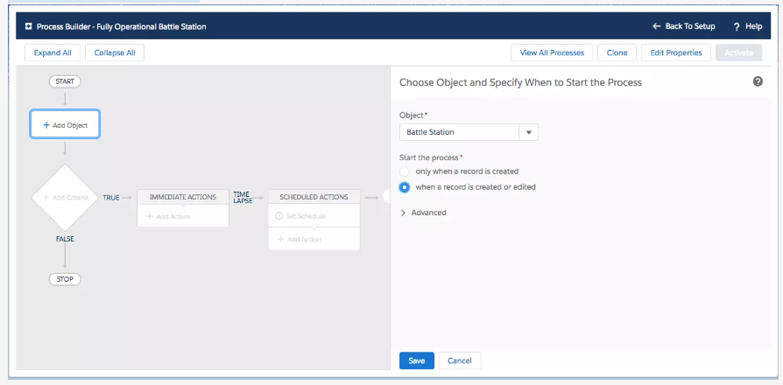

1. Click the **Save** button.
2. Click the **+ Add Criteria** icon to determine which criteria should evaluate to true to fire actions. You'll configure the process to run only if the Weapons Status value has been changed to **Fully Operational**.
3. Enter Now Fully Operational for the Criteria Name and select **Conditions are met**.
4. Click the Field picklist, select **Weapons Status** and click **Choose**. Change Operator to **Is changed** and Value to **True**.
5. Add another criteria by clicking the **Add Row** button.
6. Click the Field picklist, select **Weapons Status** (again) and click **Choose**. Change Operator to **Equals** and Value to **Fully Operational**.

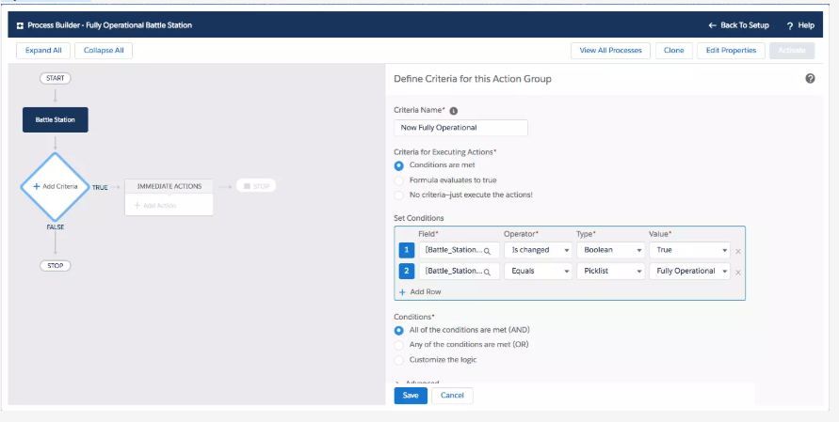

### **Update Record Action**

When the criteria evaluates to true you want to change the Project Status to **Complete**, indicating that the project is finished and your Battle Station is ready for action! Blowing stuff up with large laser cannons is actually quite relaxing.

1. Click the **+ Add Action** button.
2. For Action Type, select **Update Records**.
3. Enter Update Status as the Action Name.
4. For Record Type, click the search field and select the radio button for **Select the Battle_Station__c record that started your process** and click **Choose**.
5. Set new field values for the record to update by clicking the Field picklist, select **Project Status** and change Value to **Complete**.

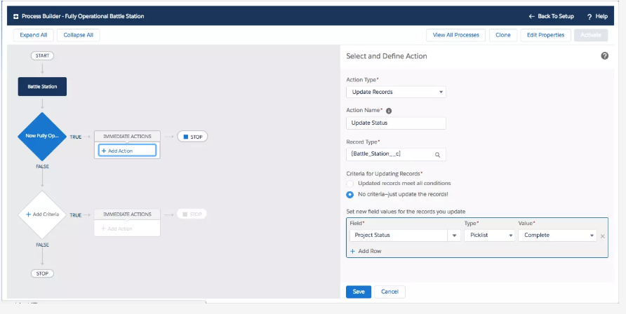

### **Post to Chatter**

One last action before we put our process into effect. When the project is complete and the weapons are operational, we want to announce our amazing accomplishments by posting a message to Chatter. This should make your boss breathe much easier.

1. Click the **+ Add Action** button.
2. For Action Type, select **Post to Chatter**.
3. Enter Post to Chatter as the Action Name.
4. For Post to, select **This Record**.

**Note**: Please make sure you have enabled Feed tracking for the Battle Station custom object to view **This Record**.

1. For the Message, enter {![Battle_Station__c].Name} is complete! Now witness the power of a fully armed and operational battle station!.

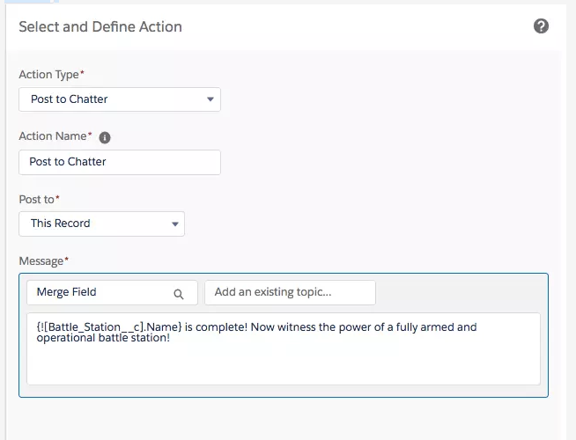

1. Click the **Save** button.
2. Click the **Activate** button in the upper right corner to... uh... activate your process. Click **Confirm**.

Now that you are finished, the entire process should look like this.

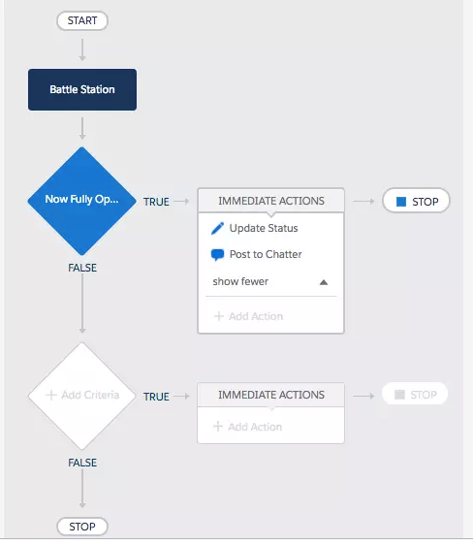

### **Test Your Process**

Time to see your process in action! Simply edit a Battle Station record, set the Weapons Status to **Fully Operational** and click **Save**. When the page refreshes the Project Status should display **Complete** and there should be a Chatter post at the right of the page announcing how awesome you are.

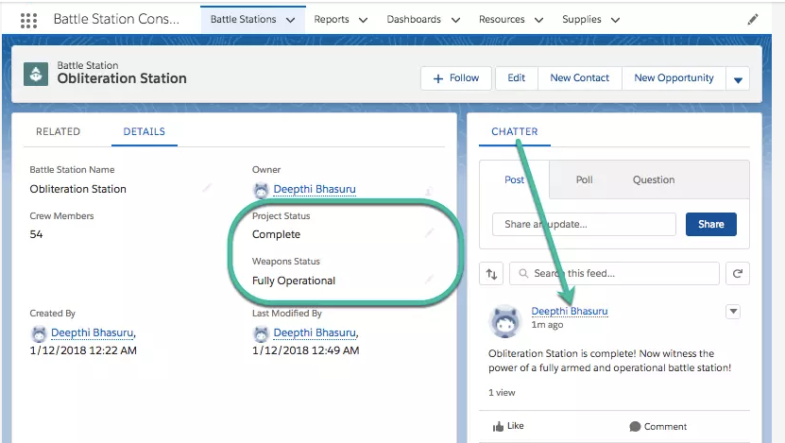

# Create Reports and Dashboards

## Create a Report

A report in Salesforce is a list of records that meet the criteria you define. It’s displayed in Salesforce in rows and columns, and can be filtered, grouped, or displayed in a graphical chart. You'll create a report to monitor your supply costs for each Battle Station being constructed.

1. Click the  and select **Battle Station Construction** then click the **Reports** tab.
2. Click **New Report...** button.
3. Expand the **Other Reports** folder, select **Battle Station with Supplies** and click **Continue**. If you don't see the Battle Station with Supplies report type, go back to Setup and click **Object Manager**. Next to Battle Station, click **Edit**. Under Optional Features, check **Allow Reports**. Click **Save**. Then go back and create the report.
4. Search for **Quantity**, **Unit Cost**, and **Total Cost** fields in the Add column search and add them as columns one at a time.

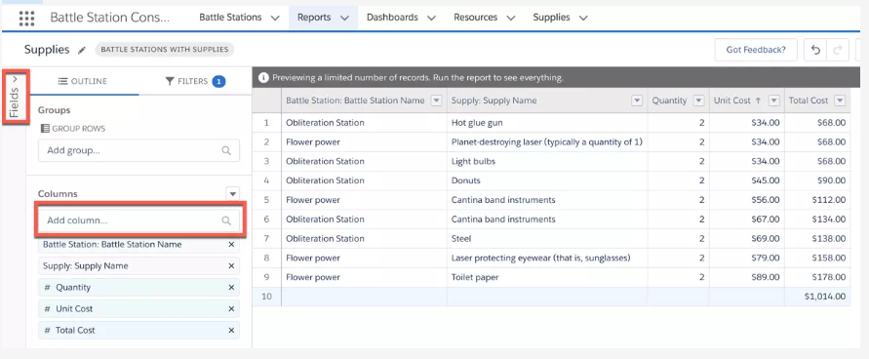

1. Note: You can also drag the fields from the **Fields** pane, in the Battle Station with Supplies: Info folder in to **Columns** section.
2. In the Add group search, enter Battle Station Name and select **Battle Station Name**. This will separate the report by individual Battle Station records

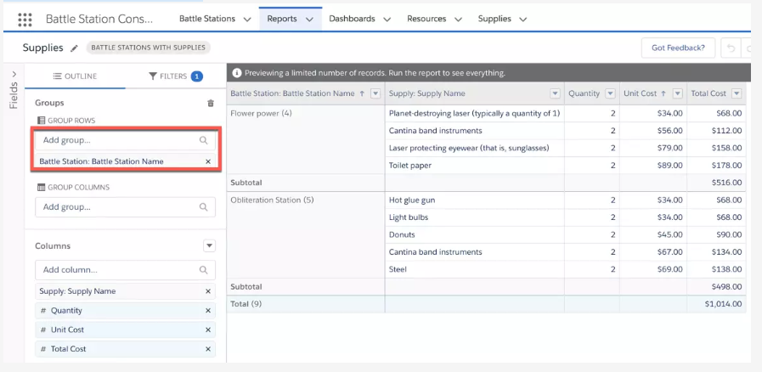

1. Open the menu on the **Quantity**, **Unit Cost** columns and select **Summarize**, then deselect **Sum**. Leave **Sum** as selected for **Total Cost** Column.

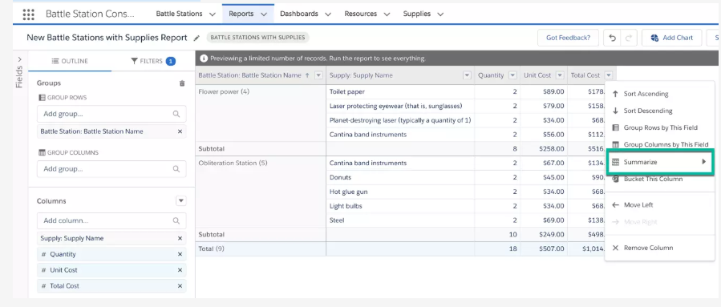

1. Click **Save & Run**, enter Supplies for the Report Name and click **Save**.

You should see something like the following with subtotals for each Battle Station. Your boss will love you and certainly give you the rest of the day off

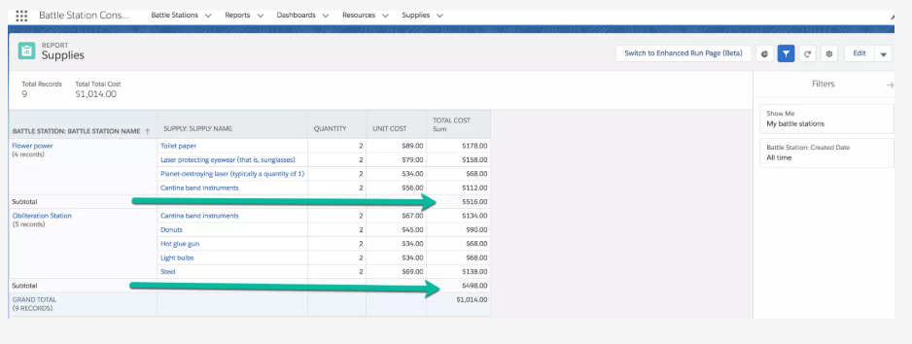

## **Create a Dashboard**

A dashboard is a visual display of key metrics and trends. The relationship between a dashboard component and report is 1:1; for each dashboard component, there is a single underlying report.

Multiple dashboard components can be shown together on a single dashboard page layout, creating a powerful visual display and a way to consume multiple reports that often have a common theme, like number of exhaust ports unsecured, toilet paper usage per Battle Station, etc.

1. Click the **Dashboards** tab.
2. Click **New Dashboard...** button.
3. Name the dashboard as Construction and click on **Create**.
4. Click the **+Component** button on the top of the page and select the **Supplies** report.
5. Select the **Vertical Bar Chart component** and click **Add**.

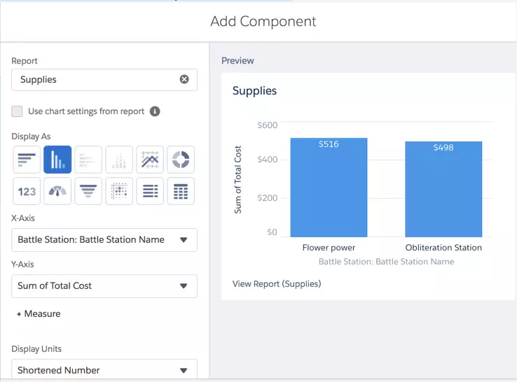

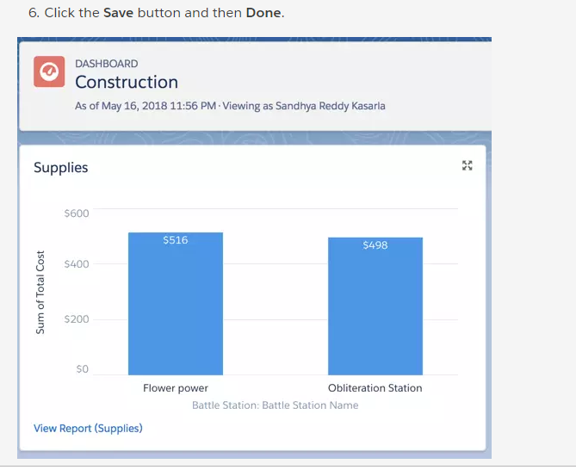

# Make the App Mobile

## Become a Mobile Developer

Your boss is determined to have a mobile app to fire off Battle Station requests from any part of the galaxy. The only problem is that your team doesn't have any mobile developers, and the boss is not gonna be happy.

However, when using Salesforce **you instantly become a mobile developer**! Using point-and-click features such as mobile navigation, compact layouts, and actions, you can mold the Salesforce mobile app into a powerful tool that your boss can use from any planet with cell reception.

You can get the Salesforce mobile app in different ways:

* As a downloadable app from the App Store and Google Play™.
* As a mobile browser app that runs in supported mobile browsers. This option doesn’t require anything to be installed.

For this step, we'll use the last option, because it's an easy way to develop and test.

1. Open a browser on your phone or tablet and navigate to http://login.salesforce.com. In the upper left corner of your screen, click the Navigation icon to open the sidebar navigation.
2. Once logged in, click the three little lines in the upper left (the navigation icon).
3. In the **Recent** section of the navigation menu, click the **More** menu item to display the **Battle Stations** option.

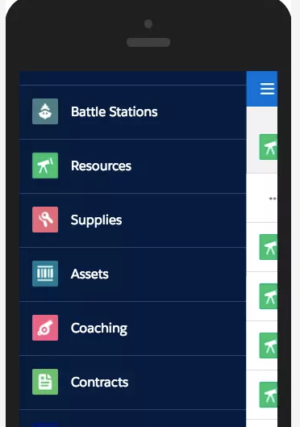

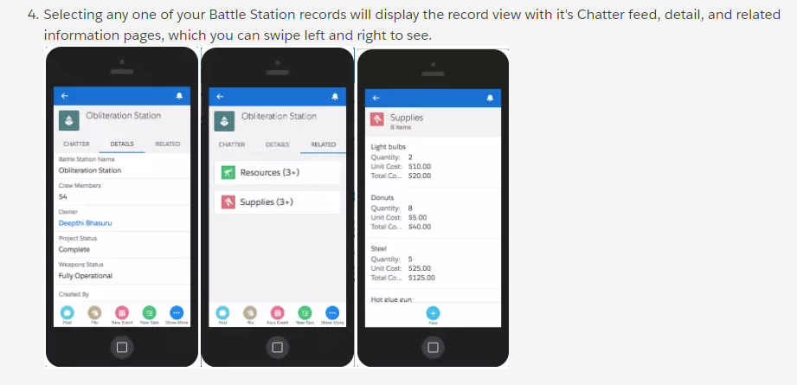

### **Create a Quick Action**

You want to make it as easy as possible for your boss to enter new records, so you'll make a button that is available from anywhere in the Salesforce mobile app and provides him with a single field to enter the Battle Station name to minimize confusion.

First let's create the Quick Action. Quick Actions are things you want to do immediately from your mobile device such as entering the name of a new Battle Station. These actions live in a special place called the Publisher. You can customize the Publisher so that your most important actions are there at your fingertips.

1. From Setup, enter Global Actions in the Quick Find, then select **Global Actions**.
2. Click **New Action**.
3. Leave the Action Type as **Create a Record**. In the Target Object field, choose **Battle Station**.
4. In the Label field, enter New Battle Station.
5. Click **Save**.
6. In the next Action Layout screen, leave **Battle Station Name** as the only field in the layout.
7. Click **Save**.

Now you need to add that Quick Action to the Publisher. The Publisher Layout determines which Quick Actions you see in the Action bar at the bottom of the Salesforce mobile app.

1. On the left side, under **User Interface** | **Global Actions**, click **Publisher Layouts**.
2. Next to Global Layout, click **Edit**.
3. Salesforce puts several Quick Actions in the Publisher by default. Feel free to remove any that you'd like by clicking it in the Global Publisher and dragging it up to the Global Layout area.
4. Now add your **New Battle Station** action by dragging it from the Global Layout and dropping it into the Global Publisher below.
5. You can move the actions around. Drag **New Battle Station** to the left so that it appears first. It's easier to find this way.
6. Click **Save**.

### **View the Quick Action**

Go back to the Salesforce mobile app and click the navigation icon (the three little lines) in the upper left and select the Chatter menu item.

When the page opens, you'll see some icons on the bottom. The first icon should be your Quick Action that creates a new Battle Station. However, you may have to click the **Show More** icon to find it. Click the **New Battle Station** icon. In your org, this action might be represented with an icon different from the Bottle icon that you see below.

